1. In earlier lecture, we send msg to activemq and from other MS, we received the msg and log it.
2. **Agenda**:
   1. In this lecture, we will send a file instead of a string (msg).
3. Graphical user interface, application

   Description automatically generated
4. **Agenda**:
   1. Now what we will do is that instead of sending msgs by using Timer (as above), we will pick a file from our local system and will publish to the Active MQ Queue.
5. Graphical user interface, application

   Description automatically generated
6. Graphical user interface, application

   Description automatically generated with medium confidence
7.   
   Table

   Description automatically generated with low confidence
8. 
9. 
10. 
11. 
12. Graphical user interface, text, application

    Description automatically generated
13. As per the above JSON MSG Structure, let’s create Bean Class.  
    Text

    Description automatically generated  
    Declare the above class to be public.
14. Graphical user interface

    Description automatically generated with medium confidence
15. 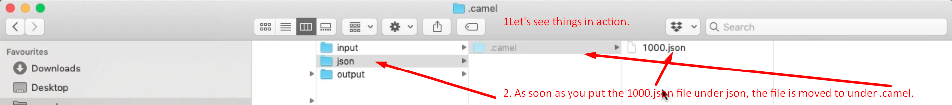
16. When you run the code, you will come across this error.  
      
      
      
    
17. **Solution**:  
    Text

    Description automatically generated
18. 